**COMPUTER PROGRAMMING**

**ASSIGNMENT # 2**



**Spring 2022**

**CSE102 Computer Programming**

Submitted by: **Ali Asghar**

Registration No. : **21PWCSE2059**

Class Section: **C**

“On my honor, as student of University of Engineering and Technology, I have neither given nor received unauthorized assistance on this academic work.”

Student Signature: ______________

Submitted to:

**Dr. Muhammad Athar Javed Sethi**

June 6, 2022

Department of Computer Systems Engineering

University of Engineering and Technology, Peshawar

**Q 1 - Write a C++ program to find the largest element of an integer array.**

**Q 2 -** **Write a C++ program to find the second smallest elements in a given array of integers.**

**CODE:**

This code is divided into following three parts. In each part, it performs a specific task which is explained below. The answer to Q1 and Q2 both is given in the code below.

**PART 1:**

This is the first part of the code. In this part, I declared certain variables and prompt the user to get the range and values stored in the array.

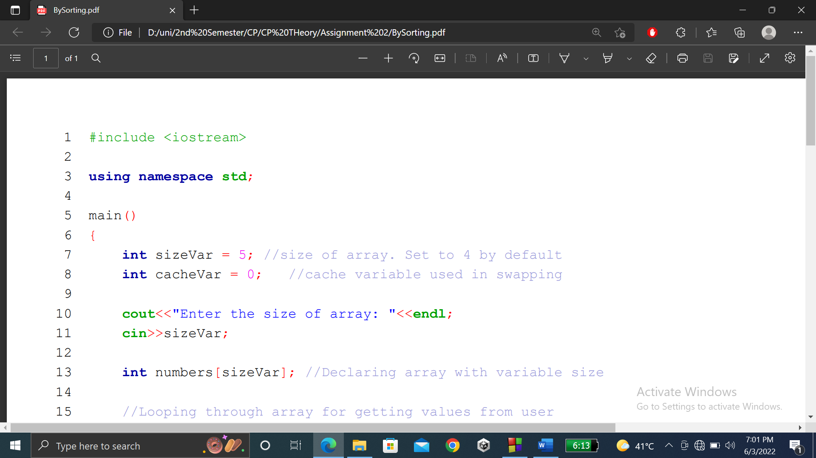

**PART 2:**

In the second part of the code, I obtained the values from user and stored the data in inside array called numbers. Then I used the bubble sort technique to sort array in ascending order

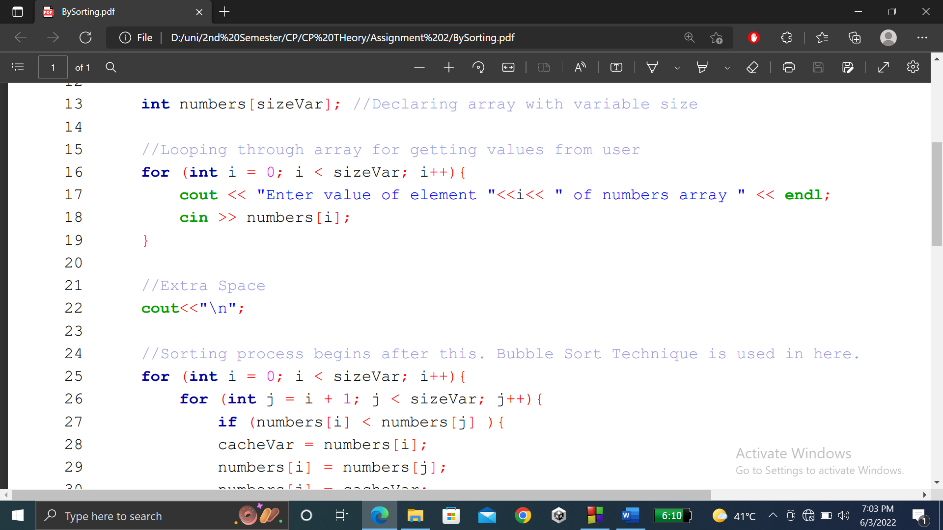

**PART 3:**

In the last part of the code, array is sorted in ascending order. Now we only want to show the 1st and 2nd last element of numbers array. Largest element is at 0 position because array 1st element is at index 0 while 2nd last element is at n-2 position of this array.

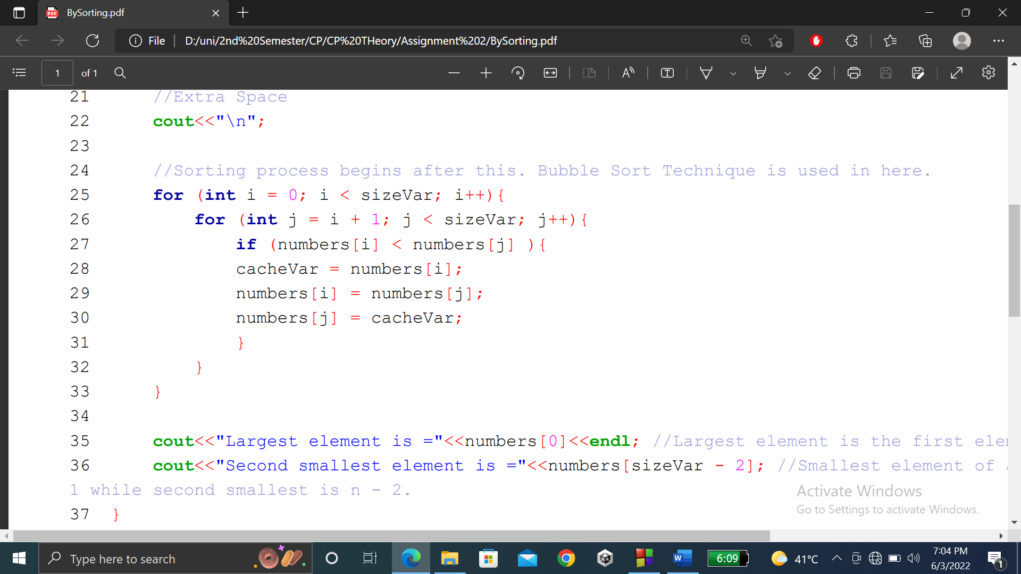

**Output:**

